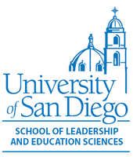
Notice of Lesson Recording

Dear Parent/Guardian:

This semester, Spring 2021, your child’s class is working with _________________________, a teacher candidate from the University of San Diego School of Leadership and Education Sciences. Teacher credential candidates are required to video one or more lessons for various purposes, including their CalTPA credential requirement from the State as well as for their observation requirements at USD. Although the video will show both the student teacher and various students, the primary focus is on the teacher candidate’s instruction and not on the students in the class. The recording will only be seen by USD faculty and assessors of the CalTPA. The assessment also contains samples of student work as evidence of learning. No student last names will appear on any submitted materials, and all materials will be kept confidential.

If you do not consent to such recording, please notify your child’s teacher. On days when recording will occur, the teacher will request that your child turn on their video during distance learning.

Sincerely,

Amanda Roth, Ph.D.
Amanda Roth, PhD, Director of Field Experiences & Professor of Practice
Department of Learning & Teaching
amandaroth@sandiego.edu

